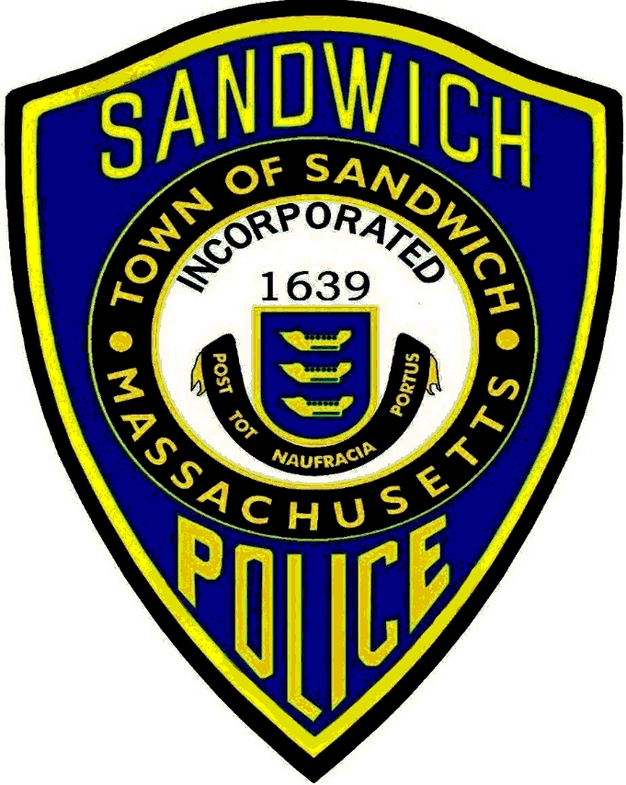
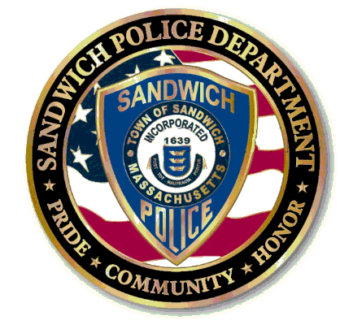

24th Annual
Sandwich Police Association
Golf Tournament

Sandwich Hollows Golf Club
Friday October 16, 2015
Rain or Shine

Registration 12:00PM * Shotgun Start 1:00PM
$110 per Player

Includes: Green Fees, Cart, Dinner

DINNER - AWARD CEREMONY &
PRIZE RAFFLE FOLLOWING TOURNAMENT

- ___________________________
- ___________________________
- ___________________________
- ___________________________

Checks Payable to: “Sandwich Police Association” 117 Route 6A Sandwich MA 02563

All Proceeds benefit the Sandwich Police Association Scholarship Charity
Please RSVP no later than October 5, 2015
FIRST COME, FIRST SERVED
Det. Sgt. Murphy
508.888.3343

